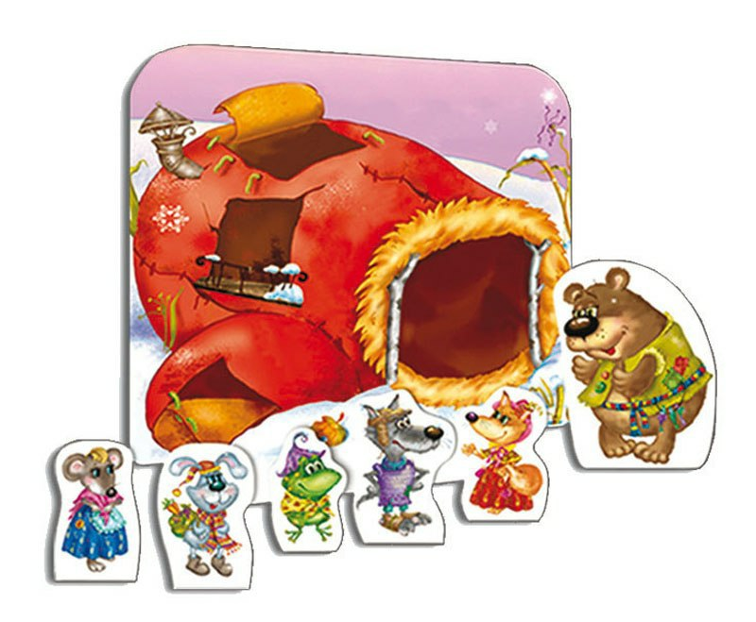

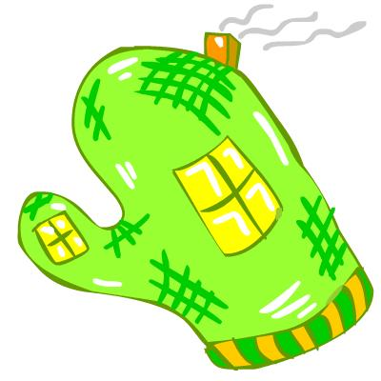

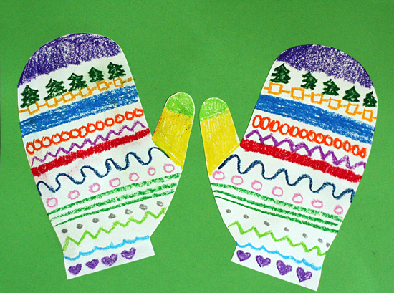

|  |  |
| --- | --- |
| http://cs543101.vk.me/v543101910/9608/pWNL8PSmcPA.jpg | http://cs543101.vk.me/v543101910/9608/pWNL8PSmcPA.jpg |